**Tutorial 04**

In this tutorial we learn how to pick up the collectables we made from the previous tutorial. This one is not that hard as well.

* Now you have collectables rotating (ref.Tutorial 03), and you have a moving Player (ref.Tutorial 02).
* We have to add a function to the PlayerMovement script that we have already.
* Open the PlayerMovement script double clicking it and go to the end of the script, line 41.

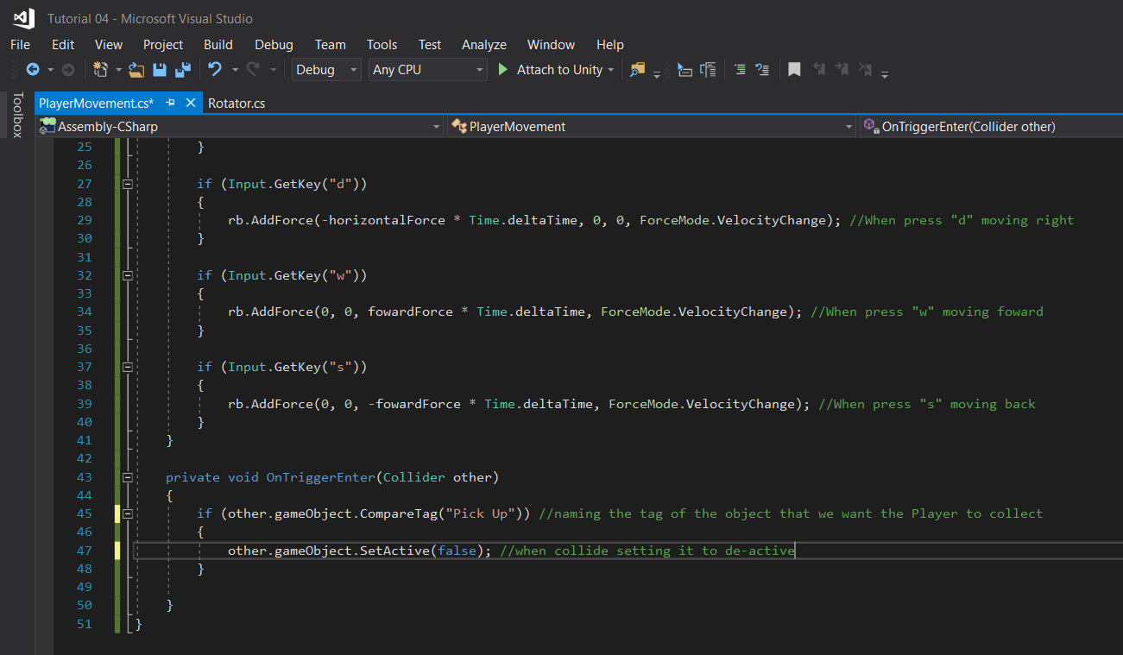

Like this, we’ll be using OnTriggerEnter function here. Make it private so it can be only accessible in this script.

Make “if” statement,

**If the game object which is tagged as “Pick Up” collide with the Player, deactivate that object.**

That’s it.

Now go to Unity and tag the coin as “Pick Up” by adding a new tag. And Press apply, from the power of prefabs it will do the same for the other coins as well.

Now press Play and test, you will see that the Player will collide with the coin but won’t pick up it. This is because we haven’t set the trigger of the coin active.

Got to the Inspector menu of the Pick Up object Coin, and under Capsule Collider you can see trigger is unticked. Set it active by ticking it and try again by pressing Play.

Yes, now it’s working.

Enjoy!

Lakshitha Abeyrathna